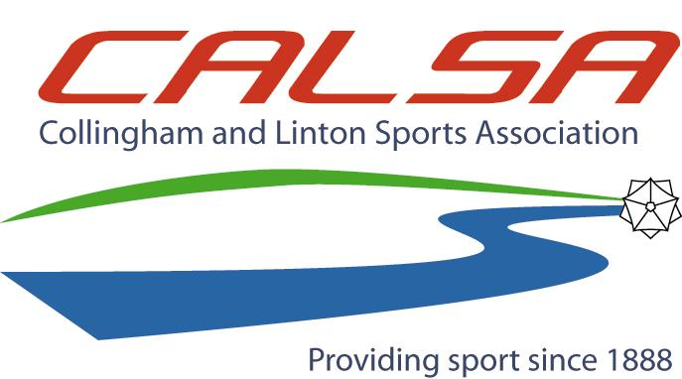

A Community Amateur Sports Club

COLLINGHAM & LINTON SPORTS ASSOCIATION
HAREWOOD ROAD, COLLINGHAM, LS22 5BL
APPLICATION FOR SOCIAL MEMBERSHIP

APPLICANT: FORENAME ................................................ SURNAME ............................................................
SIGNATURE …………………………………………………... DATE OF BIRTH ……………………………………..
ADDRESS ------------------------------------------------------------------------------
------------------------------------------------------------------------------
POSTCODE -----------------------------------------
TELEPHONE --------------------------------------------------------- MOBILE ---------------------------------------------------
E-MAIL ---------------------------------------------------------------------------------------------------------------------------
(Provision of this enables CALSA to inform members of future events)
DATE OF APPLICATION ………………………………………
The membership fee entitles the member and spouse only to Associate Membership of the Association. All Associate members are welcome to use the bar facilities and attend events as advertised from time to time. Associate Members must be aged 18 years or above.
By signing this form the applicant undertakes that the Member and any accompanying guests will abide by the Associations code of conduct and that failure to do so may result in revocation of membership with no refund of subscription.
MEMBERSHIP FEE: 1 YEAR £12 (or part thereof), 5 YEARS £50, LIFE £100
Payment can be made at the bar with presentation of this form or preferably by standing order obtained from the bar or by contacting info@calsa.co.uk
VAT number 171498933

The information you provide in this form will be used solely for the purpose of processing your application and dealing with you as a member of Collingham & Linton Sports Association. Your data will not be shared with any third party without your explicit consent.

